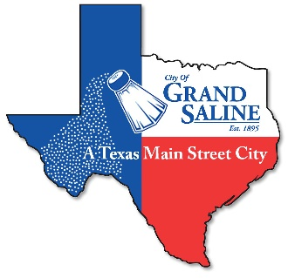 CITY OF GRAND SALINE
132 East Frank Street Grand Saline, TX 75140 Phone: (903) 962-3122 Fax: (903) 962-3363

PET LICENSING/REGISTRATION FORM
Ordinance 2017-107 Ordinance 2022-127 Ordinance 2023-103

This is just a partial list of the information in the City of Grand Saline’s Ordinances.

License: A license/registration is required for each dog and/or cat, up to four (4)
Vaccinate: Rabies vaccinations are required for dogs and cats
Leash: Dogs must be on a leash and under your control at all times unless inside your home or within a completely fenced yard.
Clean-up: Pet Waste must be cleaned from walks and property not belonging to owner.
Be Responsible: Pets cannot unreasonably disturb the peace and cannot be left unattended in a motor vehicle in a way that endangers their safety.

FINES FOR VIOLATIONS CAN BE UP TO $2,000.00
Licensed pets are easier to identify and return to their owner.
Licenses are faster to track than rabies tags and other forms of identification.
Licenses are proof of ownership.
LICENSE/REGISTRATION FEE $10.00

OWNER INFORMATION
Name:______________________________________Phone:______________________

Address:________________________________________________________________

DESCRIPTION OF ANIMAL
Breed:__________________ Name:_________________ Age:______ Sex:__________

Spayed/Neutered:_______Description:_______________________________________

Current Vaccinations:_____________________________________________________

